**KEYLOGGER**

This is a simple Python-based keylogger that captures keyboard input and sends it to an email. The keylogger runs in the background and logs keystrokes, then periodically sends them to your specified email address.

**Pre-Requisites**

1. Install required libraries

* Install pynput *# pip install pyput*
* Install requests *# pip install requests*

1. A server or email account to receive logged data

**Step 1:**

Import Required Libraries

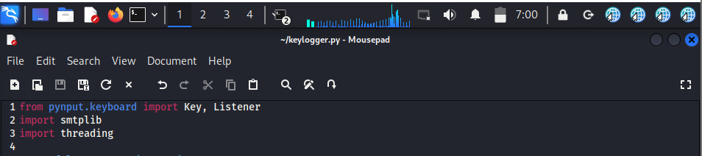

**Step 2:**

Create a log file to store the key strokes

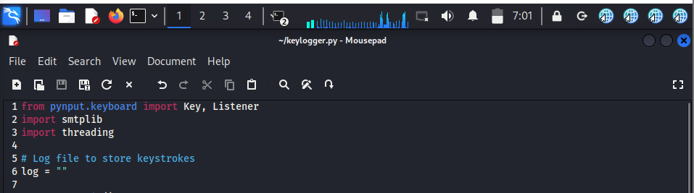

**Step 3:**

Send Logs to a Remote Server

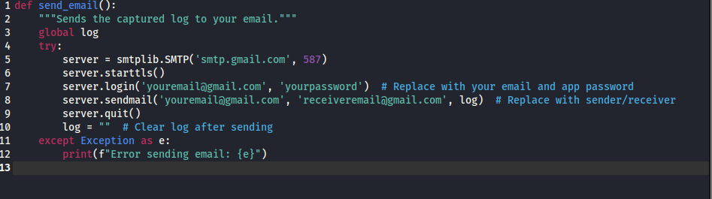

**Step 4:**

Run the key logger using the listener class

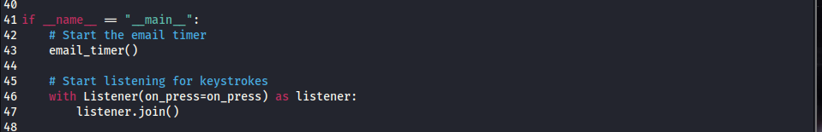

**Steps to Run**

1. **Run the Script**: Save the script as keylogger.py and execute it:

*python keylogger.py*

1. **Monitor Logs**: Check the specified email for captured logs.

**Important Notes**

1. **Security**:
   * Use **App Passwords** for Gmail instead of your primary password for security.
   * Avoid storing sensitive data in the script.
2. **Ethical Usage**:
   * Test only on systems you own or have explicit permission to test.
   * Inform users and obtain written consent.
3. **Anti-Virus Detection**:
   * This script might be flagged as malicious. Disable antivirus only on testing environments.

**Common Use Cases**

1. **Sending Notification Emails**: Automatically send alerts from a Python application.
2. **Automating Reports**: Email periodic logs or reports to stakeholders.
3. **Testing Email Delivery**: Quickly verify SMTP server configurations.